 | DAY 1
14h00 – 14h30 | WELCOME
14h30 – 15h30 | TRANSFER  Transfer from the Lisbon Airport to Sesimbra.
15h30 – 16h30 | BRIEFING  Presentation of the 6 days Channel and Long Distance Training Camp Sesimbra.  ACCOMMODATION OVERVIEW  Visit to the Sesimbra Hotel & Spa.
16h30 – 18h30 | OPEN WATERS  Warm Up + Short Swim + Stretching.
18h30 – 19h30 | REST TIME  In the Sesimbra Hotel & Spa.
19h30 – 21h00 | DINNER  In a Restaurant in Sesimbra.

 | DAY 2
7h00 – 8h00 | BREAKFAST
8h00 – 12h30 | POOL SESSION  Warm Up + Pool Training w/ video analysis of your technique + Stretching.
12h30 – 14h00 | LUNCH  In a Restaurant in Sesimbra.
14h00 – 16h00 | REST TIME  In the Sesimbra Hotel & Spa.
16h00 – 19h30 | OPEN WATERS  Warm Up + 2-hour Afternoon Sea Swim+ Stretching.
19h30 – 21h00 | DINNER  In a Restaurant in Sesimbra.

 | DAY 3
7h00 – 8h00 | BREAKFAST
8h00 – 12h30 | OPEN WATERS  Warm Up + 3-hour Sea Swim+ Stretching.
12h30 – 14h00 | LUNCH  In a Restaurant in Sesimbra.
14h00 – 16h00 | REST TIME  In the Sesimbra Hotel & Spa.
16h00 – 19h30 | OPEN WATERS  Warm Up + 1-hour Sea Swim+ Stretching.
19h30 – 21h00 | DINNER  In a Restaurant in Sesimbra.

 | DAY 4
5h00 – 5h30 | BREAKFAST
5h30 – 12h30 | OPEN WATERS  Warm Up + 6-hour Sea Swim w/Night Swim+ Stretching.
12h30 – 14h00 | LUNCH  In a Restaurant in Sesimbra.
14h00 – 19h30 | REST TIME  In the Sesimbra Hotel & Spa.  YOGA SESSION  At the Sesimbra Beach.
19h30 – 21h00 | DINNER  In a Restaurant in Sesimbra.

 | DAY 5
7h00 – 8h00 | BREAKFAST
8h00 – 12h30 | OPEN WATERS  Warm Up + 1-3 hour Recovery Sea Swim+ Stretching.
12h30 – 14h00 | LUNCH  In a Restaurant in Sesimbra.
14h00 – 18h00 | VISIT  Visit Sesimbra and surroundings.
18h00 – 19h30 | REST TIME  In the Sesimbra Hotel & Spa.
19h30 – 21h00 | DINNER  In a Restaurant in Sesimbra.

 | DAY 6
7h00 – 8h00 | BREAKFAST
8h00 – 10h30 | OPEN WATERS  Warm Up + Optional Easy Morning Swim+ Stretching.
10h30 – 11h30 | BATH TIME  In the Sesimbra Hotel & Spa.
11h30 – 13h00 | LUNCH  In a Restaurant in Sesimbra.
13h00 – 14h00 | DEPARTURE  Transfer from Sesimbra to the Lisbon Airport. Until the next adventure!

WHAT IS INCLUDED?

- Safety in and out of water
- Company of experienced guides
- Food supply in training
- Transfers during the Swim Camp
- Technique coaching and video analysis
- One Yoga Session
- One Night Swim
- 5 nights in a 4-star hotel accommodation with sea view, direct beach access and covered parking (garage)
- Free use of the following spa services: small indoor pool, sauna, turkish bath, tropical shower, swiss shower and gym
- All meals (Breakfast + Lunch + Dinner)

WHAT IS NOT INCLUDED?

- Training Equipment
- Flights
- Drinks other than waters during meals (Lunch and Dinner)
- Extra snacks during the supply of activities
ACTIVITY DESCRIPTION

If you are training for a challenging long-distance open water swim in cold water, this trip is designed for you.
Under the expert eye of our experienced swim coaches, you will have all the support that you need to complete six days of intensive open water training.
It is ideal for those planning to undertake a solo crossing of the English Channel, Cook Strait, Catalina Channel, Strait of Gibraltar, Manhattan Island Marathon Swim, North Channel, Molokaʻi Channel or Tsugaru Strait.

WHO CAN PARTICIPATE?

The experience of outdoor swimming can be challenging, but extremely out of the ordinary. Having a natural self confidence to swim in open waters is an asset. The minimum swimming speed is 30min/km.
MEETING POINT

Location: Lisbon Airport.
Address: Alameda das Comunidades Portuguesas, 1700-111 Lisboa.
Start Time: 2:00 P.M. on Day 1.
End Time: 2:00 P.M. on Day 6.

EQUIPMENT REQUIRED
In addition to your daily non-swimming clothes, we also recommend that you bring the following items:
 | ITEM |  | ITEM
☐ | Swimming Costume (x 2) | ☐ | Towels
☐ | Swimming Goggles (x 2)* | ☐ | Small Backpack
☐ | Wetsuit | ☐ | Waterproof Trousers / Jacket
☐ | High Factor, Water Resistant Sun Cream | ☐ | Sweater / Fleece / Woolly Hat / Hat / Gloves and Warm Socks
☐ | Swim Earplugs (if you use them) | ☐ | Waterproof Watch
☐ | Tracksuit Trousers / Sweatpants | ☐ | Thermal Underwear / Base Layers
☐ | Aqua Shoes / Sandals / Slippers | ☐ | Any Specific Nutritional Needs
* Try to bring one clear lens and one tinted lens for different light conditions.
Extra: If you need some material to carry out the experience you can rent at the meeting point. For this, we need you to request us until 24 hours before the start of the activity.

ACCOMPANYING

This activity may be accompanied by family or friends who travel with you. Each escort may choose to accompany you in a kayak. Children may also be present since supervised by an adult. The companions are an excellent complement to the safety of the activity.

SWIMMING DISTANCE

This swimming experience takes place along Natural Park of Arrábida and Sesimbra Coast and is approximately 50km. Click here to see all crossings.
DAY 1
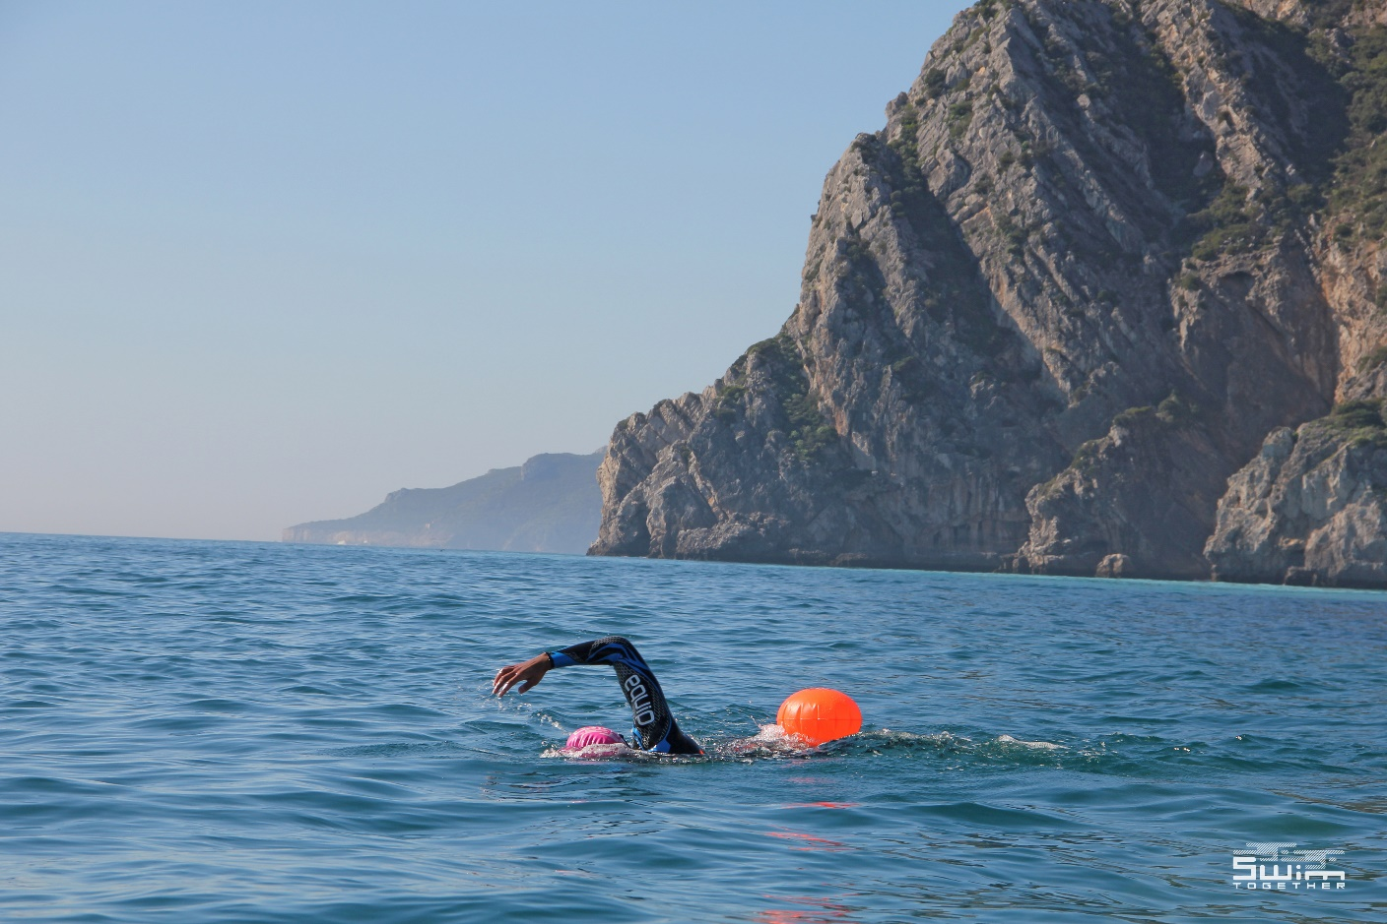

DAY 2
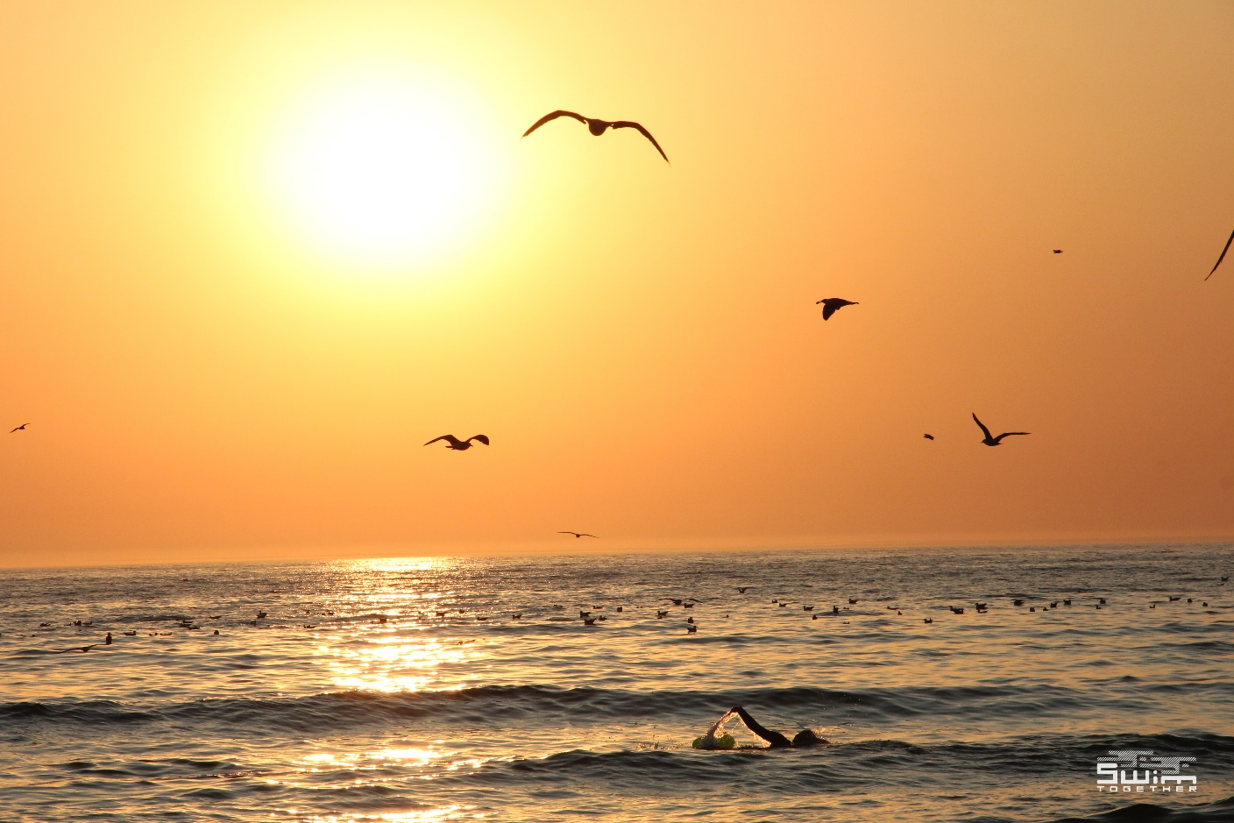
DAY 3
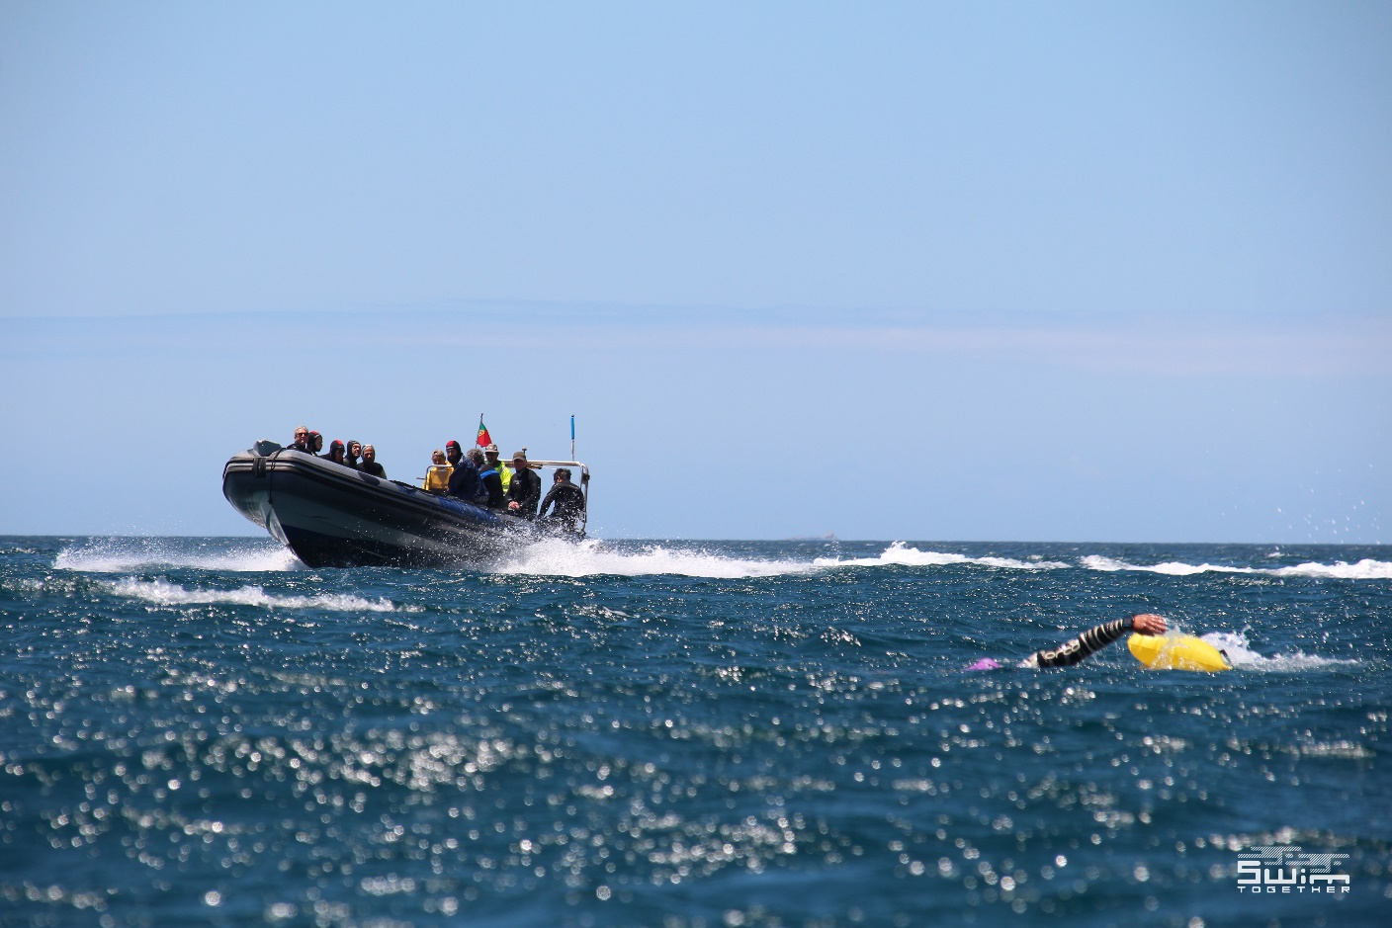

DAY 4
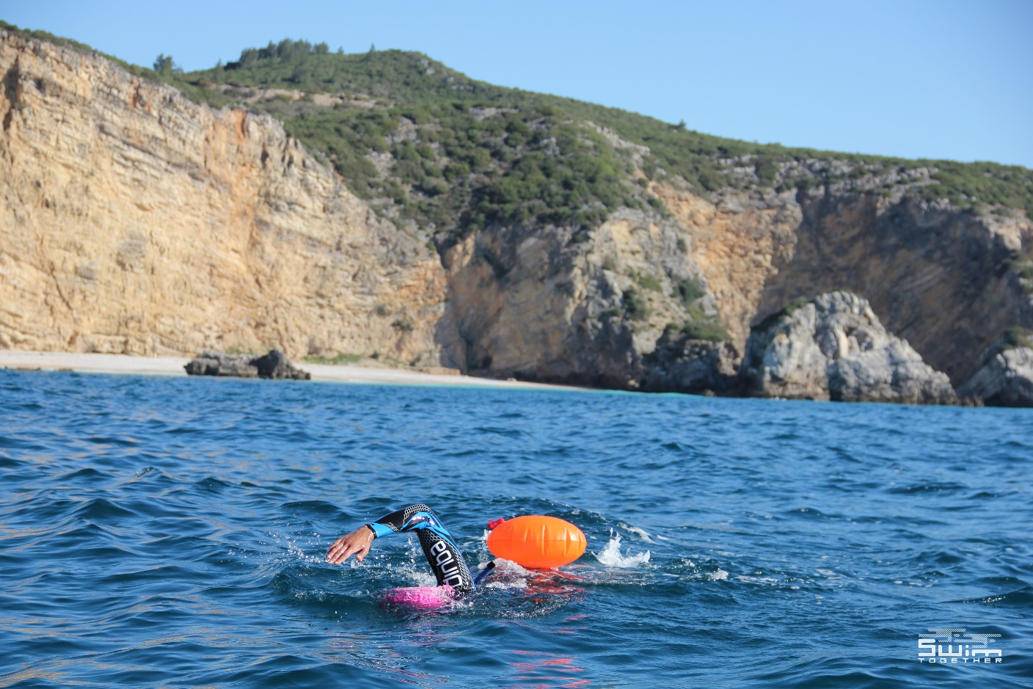

DAY 5
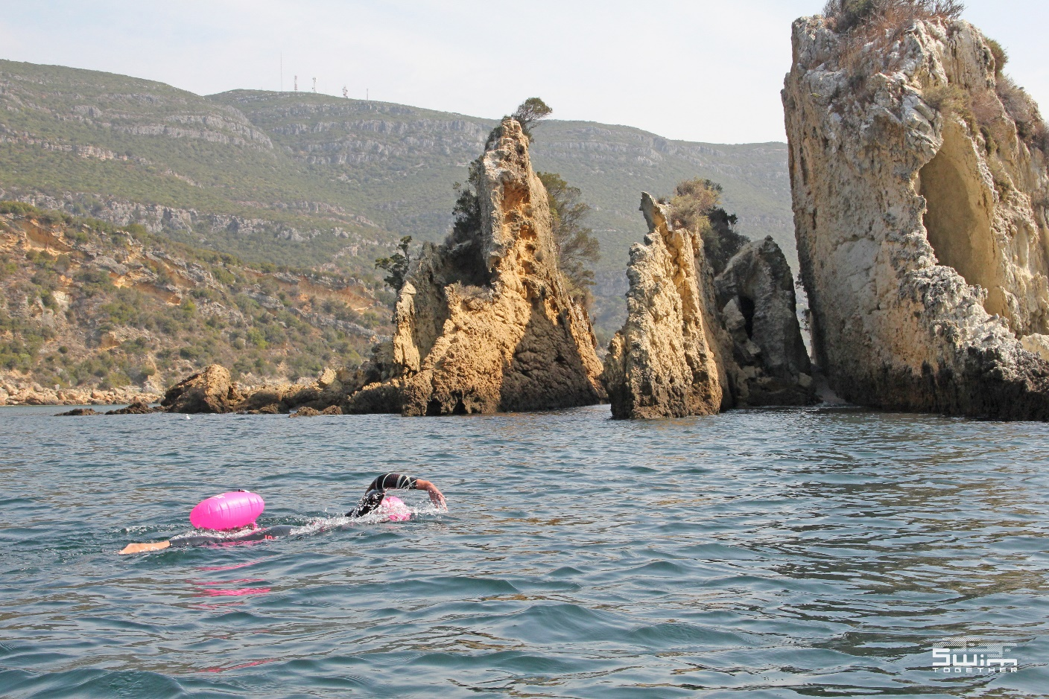

DAY 6
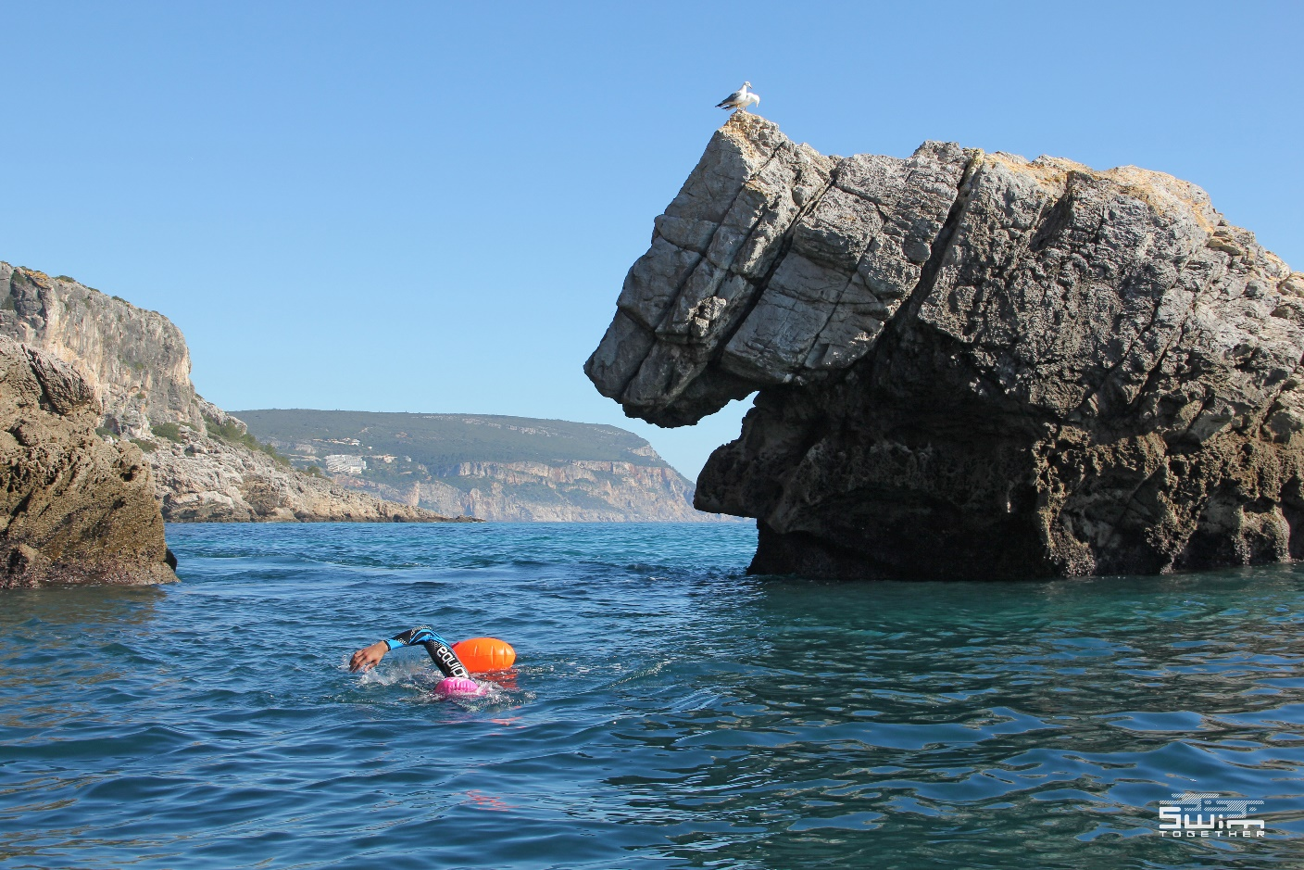
ACCOMMODATION

The 4-Star Sesimbra Hotel & SPA is a panoramic hotel with prevailing view over the Atlantic Ocean and a privileged location on the beachfront of Califórnia. With direct access to the beach, you can contemplate an ocean of sensations and immerse yourself in a wave of pure evasion, in the poetry of the moment. It is located 1 hour from Lisbon Airport, 30 minutes from Arrábida and 40 minutes from Setúbal.
All the facilities in your room:

- Double room w/ single upgrade
- Sea view room
- Private balcony
- Cable TV with plasma display
- Mini bar
- Free WiFi
- Air conditioning
- Work desk and telephone
- Room service: from 8h to 24h
- Safe (free of charge)
- Connecting rooms (family rooms)
- Hairdryer, robe and slippers
- Rooms prepared for disabled people

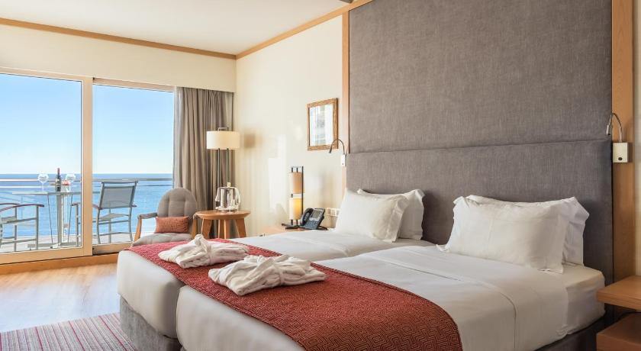
SEA CONDITIONS

Swimming in the sea is a unique experience, however, you should be aware that contact with marine species such as jellyfish, sea urchins, seaweed during dives is normal. In addition, the sea conditions and atmospheric conditions themselves may make the swimming more challenging.

WATER TEMPERATURE

The average temperature during the year is between 13ºC and 16ºC (55,4ºF and 60,8ºF), reason why the use of isothermal fact is advised.

GROUP SIZE

This activity has a maximum of 12 participants, including companions. There will be 2 groups, according to the speed of each swimmer. Each group is escorted by a security team.
SAFETY

Throughout the activity you will be accompanied by an experienced team present in kayaks and a boat. At any time you can ask for assistance to rest, get out of the water or to feed yourself with the supplies we offer you. Our team is composed of experienced guides.

GUIDE
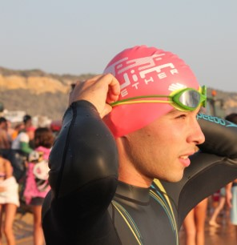
ANDRÉ SANTOS
Founder & CEO at Swim Together
André Santos is an entrepreneur. With only 20 years old opened his own business. Unsatisfied by nature, he can not stand still, dedicating his time to what he likes the most: to create and to explore. Not only is the voice of the project, but also responsible for motivating his team to follow his dream. What moves him is the will to "make it happen," believing that "difficult is different from impossible".

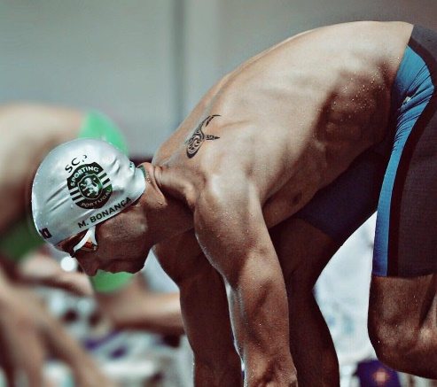
MÁRIO BONANÇA
PhD, Open Water Swimming | Swimming Coach | National Paralympic Commettee
Mário Bonança is a swimming coach and an international open water swimmer, that was the first european man studying about training, tatics and nutrition in open water. His deep knowledge about these subjets conducted him to an amazing PhD guide for all swimmers.
As a high performance swimmer he used to do 75Km per week and had the determination to follow his own convictions: “Nobody achives nothing alone” and “ If you want to be the best, you have to work and be disciplinated”.

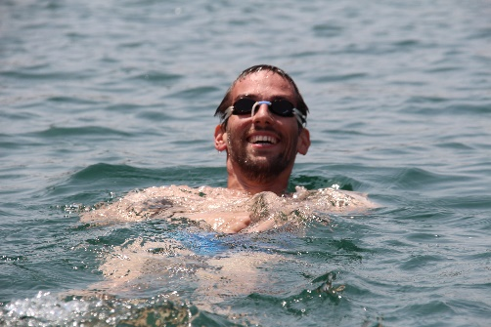
PEDRO PRAZERES
Swim Guide & Coach at Swim Together
Pedro Prazeres is a swimming coach and competitive swimmer. He has been competing for 20 seasons in different clubs and countries, and has coached teams in Portugal, Spain, Norway and the Faroe Islands.
Currently an MSc student in Performance Coaching, he applies the knowledge obtained through all the years of competition and the different realities of coaching in several countries to his practices. He loves swimming above all else and believes in persistence and technical development as the bases for performance.

